Immigration to the United States
Focus Words
noun | verb | present participle
migration | to migrate | migrating
emigration | to emigrate | emigrating
immigration | to immigrate | immigrating
refugee | to seek refuge | seeking refuge
push factors
pull factors

Moving away from one's home country is emigrating. Moving away from home is always hard because it often means leaving behind family and friends. However, millions of people around the world make this decision every year. And many of these people come to the United States.

Immigration is moving into a new country. Immigrants enter into a new environment where they need to learn many new things, like learning a whole new language. Adjustment to these changes can be very hard. People often bring their culture and traditions from their old country into their new country to make themselves more comfortable. Migration stream is the constant flow of migrants from one country into another. Today, the largest migration stream into the United States is from Mexico.

Push and pull factors drive people to move out of and move into countries. Push factors , such as food shortage, lack of jobs, encourage people to emigrate (or leave) their home country. Pull factors attract people to move into a new country. These factors include freedom and opportunities for a better life. Push and pull factors have helped drive migrations throughout history.

Since 1820, more than 65 million people have come to the United States. This enormous migration came in 3 big waves.
- The first great wave of immigration began with the founding of the United States. These early immigrants, who were escaping hunger and poverty, came mostly from northern Europe.
- In the late 1800s, a second wave of immigrants began to arrive from eastern and southern Europe. Many, who were fleeing from war or persecution because of their religion beliefs, became refugees. Also many were also fleeing from hunger and poverty.
- In the late 1960s, a third great wave of immigration began and is still going on today.

FOCUS WORDS OF THE WEEK

Migration (noun) the movement of people from one country to another
FORMS: ____________________________________________________________________________
EXAMPLES OF USE: _____________________________________________________________________
NOTES: _________________________________________________________________________________

Migration stream (noun) the constant flow of migrants
FORMS: ____________________________________________________________________________
EXAMPLES OF USE: _____________________________________________________________________
NOTES: _________________________________________________________________________________

Emigrate (noun) moving away from one’s home country to another country
FORMS: ____________________________________________________________________________
EXAMPLES OF USE: _____________________________________________________________________
NOTES: _________________________________________________________________________________

Immigration (noun) to move to a country; people who move are immigrants
FORMS: ____________________________________________________________________________
EXAMPLES OF USE: _____________________________________________________________________
NOTES: _________________________________________________________________________________

Refugees (noun) people who have fled their homes out of fear
FORMS: ____________________________________________________________________________
EXAMPLES OF USE: _____________________________________________________________________
NOTES: _________________________________________________________________________________

Pull factors (noun) something that encourages people to move to a new country
FORMS: ____________________________________________________________________________
EXAMPLES OF USE: _____________________________________________________________________
NOTES: _________________________________________________________________________________

Push factors (noun) something that encourages people to people to leave a place behind
FORMS: ____________________________________________________________________________
EXAMPLES OF USE: _____________________________________________________________________
NOTES: _________________________________________________________________________________

Examples of use of underlined tier 2 words: _____________________________________________

Immigration to the United States

The following pie charts give some examples showing that migration has happened in different parts of the world and at different times. For various reasons, have been pushed from their native countries and pulled to the United States and Canada – as well as other countries that are not shown here.

1. Which country had the least emigrants who would come to the U.S. in 1951-60 and the most in 1971-70?
2. What is the difference between the percentage of Latin American immigrants to the U.S. in 1971-80 and 1951-60?
3. Who has the largest percentage of Asian immigrants -- the U.S. or Canada?
4. Who has the largest most recent percentage of European immigrants -- the U.S. or Canada?
5. The immigrant population of Canada is part of what wave of immigration?
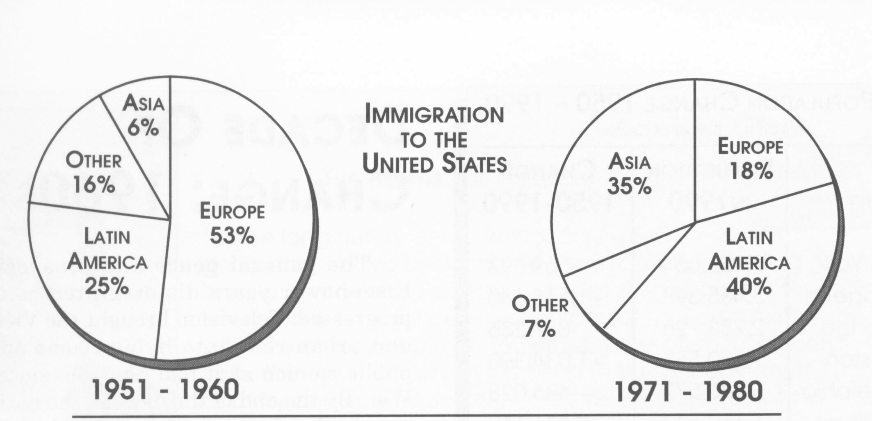

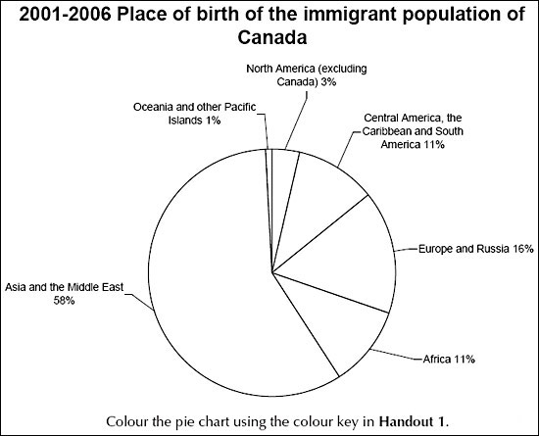
Immigration to the United States

WRITE ABOUT IT: Explain how the United States is known as a land of immigrants, using the focus words to help you.

_____________________________________________________________________________________________________________________________________________________________________________________________________________________
_____________________________________________________________________________________________________________________________________________________________________________________________________________________
_____________________________________________________________________________________________________________________________________________________________________________________________________________________
_____________________________________________________________________________________________________________________________________________________________________________________________________________________
_____________________________________________________________________________________________________________________________________________________________________________________________________________________
_____________________________________________________________________________________________________________________________________________________________________________________________________________________
_____________________________________________________________________________________________________________________________________________________________________________________________________________________

